Japanese title, subtitle and author name(s) are optional.

論文の作成について＊

（副題がある場合は括弧でくくる）

ばね太郎**，技術次郎***

Making Research Paper＊  
（Subtitle should be in parentheses）

Taroh BANE** and Jirou GIJYUTSU***

When preparing the manuscript, carefully read and observe this sample as well as the Rules of Writing for Transactions of JSSE (Japan Society of Spring Engineers). This sample was prepared using MS-word. The character size of the title shall be 14 pts of Times New Roman as well as subtitle, and that of the author name(s) shall be 12 pts. The character size of the abstract and key words shall be 10 pts of Times New Roman. The character spacing of the abstract is narrowed by 0.2 pts preferably. ---------------------------------------------------------------------------------------------------------------------------------------------------------------------------------------------------------------------------------------------------------------------------------------------------------------------------------------------------------------------------------------------------------------------------------------------------------------------------------------------------------------------------------------------------------------------------------------------------------------------------------------------------------------------------------------------------------------------

*Key Words* : Mechanical Engineering, Spring, Coil

1. Preface

This template is prepared following the Rules of Writing for Transactions of JSSE.

Each page should be divided into two columns and the number of lines in each column should be set as 50.

2. Symbols and units

*L* : Length [m]

*t* : Time [s]

σ : Stress [Mpa]

Quantifiers should be written in italics, units in roman and dimensionless numbers in italics. All units should conform to SI, for example 4 Mpa.

3. Titles of chapters and sections

The number and title of a chapter should be bold and center-justified. The number and title of a section should be bold and left-justified.

**3.1 Indention and space between lines**

The number and title of a chapter or section should be separated by two- letter space. Each paragraph should be indented by two letters.

Make one-line space between each chapter title and the first line of the text.

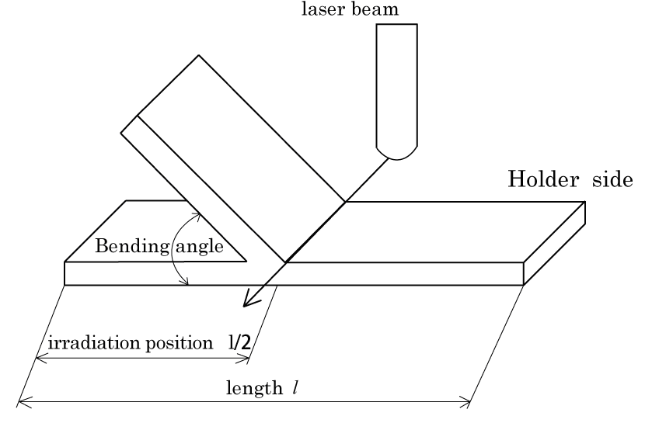

Fig. 1 Sample of a figure.

原稿受付日 0000年00月00日 Manuscript received date:

＊ 日本ばね学会0000年度○季講演会 Presented at JSSE semiannual lecturer meeting:

＊＊ ばね技術大学 Bane Gijutu University

＊＊＊ ばね工業株式会社 BANE CO, LTD

Table 1 Chemical composition.

|  |  |
| --- | --- |
| Steel | C（wt％) |
| SUP3 | 0.83 |
| SUP6 | 0.60 |
| SUP7 | 0.60 |

Table 2 Sample of root and division.

|  |  |
| --- | --- |
| Recommended | Not recommended |
|  | √ |
|  |  |

Table 3 Chemical composition of steel.

|  |  |  |  |  |  |  |  |
| --- | --- | --- | --- | --- | --- | --- | --- |
| Steel | Element（mass％） | | | | | Heat treatment (℃) | |
| C | Si | Mn | Cr | other | Quench | Temper |
| SUP3 | 0.83 | 0.25 | 0.45 | - | - | 845(oil) | 475 |
| SUP6 | 0.60 | 1.65 | 0.85 | - | - | 845(oil) | 505 |
| SUP7 | 0.60 | 2.00 | 0.85 | - | - | 845(oil) | 515 |
| SUP9 | 0.53 | 0.25 | 0.80 | 0.80 | - | 845(oil) | 485 |
| SUP9A | 0.60 | 0.25 | 0.85 | 0.85 | - | 845(oil) | 490 |
| SUP10 | 0.51 | 0.25 | 0.80 | 0.95 | V 0.20 | 855(oil) | 505 |
| SUP11A | 0.60 | 0.25 | 0.85 | 0.85 | B ＞0.0005 | 845(oil) | 490 |
| SUP12 | 0.55 | 1.40 | 0.75 | 0.75 | - | 845(oil) | 540 |
| SUP13 | 0.60 | 0.25 | 0.85 | 0.80 | Mo 0.30 | 845(oil) | 540 |

・・・・・・・・・・・・

4. Figures, tables and photographs

(1) Photographs should be treated as figures, that is, the numbers of photographs should be in serial with those of figures.

(2) The caption of a table should be located above the table and that of a figure, below the figure.

(3) Make one or more blank line between the text and a figure or table for easier reading.

(4) Each caption of figures and tables should start with a capital letter.

(5) Oversized figures and tables can use two columns.

(6) Margins at the side of small figures and tables cannot be used as text areas.

5. Forms of writing numerical expressions

All numerical expressions should be given serial numbers and each serial number should be justified to the right in parentheses. When referred to in the text, each numerical expression should be written as Equation (1) or Eq. (1).

Each numerical expression should be indented by two letters and given enough lines to be written with proper font size. (Ex. Do not pack an equation that requires two-line space into one line.) A blank line should be made between each equation and text and between equations for easier reading.

In principle, the font size of equations should be the same as that of the text. However, it can be adjusted properly when the suffix is too small to read.

 (1)

 (2)

・・・・・・・・・・・

Equations are preferably written in one-column width but can be written using two-column width. In that case, however, authors should be careful not to confuse the readers.

6. List of references

　List of references should be written at the bottom of an article and each reference should be given a serial number with a parenthesis. When a reference in the list is cited in the text, the serial number should be put in as a superscript. (Ex. This is a sample1) – 3). This is the second sample1),2).

(3)　 （4）

・・・

・・・・・・・・・

7. Conclusion

This template will enable you to follow the Rules of Writing for Transactions of JSSE automatically when you prepare an article. This must be convenient for you but there may be some parts that are not complying with the rules. So, please compare your article with archives of Transactions of JSSE and make an adjustment as needed.

References

1. Tsuyoshi Baba, Machiko Mikura, Iron and Steel, 71-5(1991), 635.
2. Erisman, R. I, Trans.ASME, B, 82-3(1960), 439.
3. Taro Suzuki, Transactions of JSSE, No.30, (1985), 15.
4. Oki Haneda, Transactions of JSSE, No. 45, (1990), 20.
5. Mikura Kanda, “History of Springs”, (1990), P.120, Spring Research Corp.
6. Goldman,J.E, "The Science of Engineering Materials", (1975), P.421, John Wiley & Sons.